**UMUC USCrimeStatistics Test Plan**

Files: USCrimeClass.java, TestCrime.java, Menu.java, CsvToArray.java, ArrayUtils.java, Crime.csv

Author: John Bernat

Date: 18Dec2016

CMIS141 – Final project

**Description:**

This program presents a user with a menu for the user to choose from a list of questions to be answered about US crime statistics. The program gets its data from a csv file that is entered in at the command line as an argument and then stored in a multidimensional array. The program has multiple classes which separate functionality, creating a more modular and design with simpler classes to manage/maintain. The menu will continue to prompt the user until the user decides to end the program. At the end of the program the amount of time the program ran will be returned in seconds.

*Note: assume (enter) after all user input.*

**Test Case 1: No argument**

|  |  |  |  |
| --- | --- | --- | --- |
| **Command entered** | **Expected output** | **Actual output** | **Pass/fail** |
| Java TestCrime | There was an issue. Please make sure you specify a file. | There was an issue. Please make sure you specify a file. | pass |

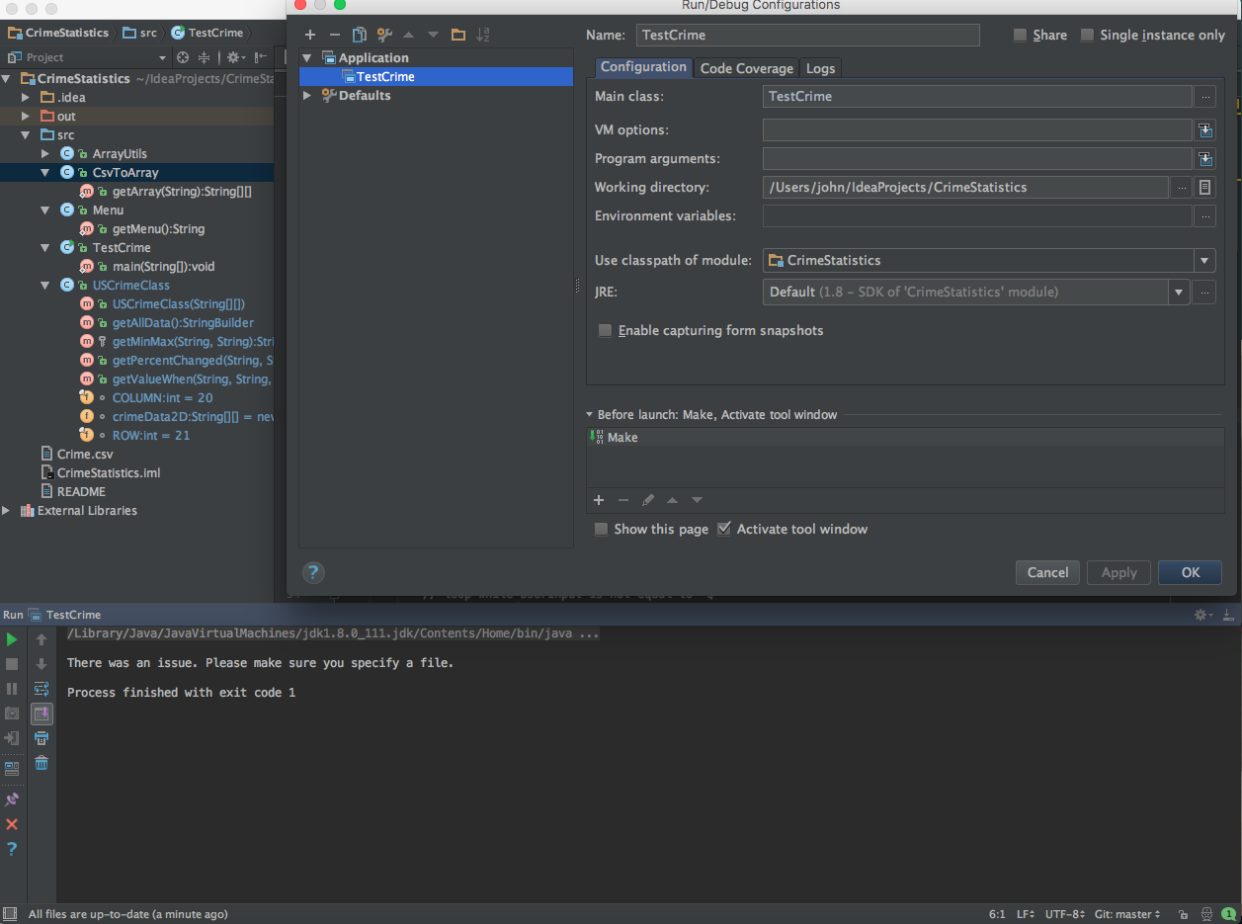

**Test Case 2: Incorrect argument**

|  |  |  |  |
| --- | --- | --- | --- |
| **Command entered** | **Expected output** | **Actual output** | **Pass/fail** |
| Java TestCrime crmie.csv | There was an issue. Please make sure you have the correct file. | There was an issue. Please make sure you have the correct file. | pass |

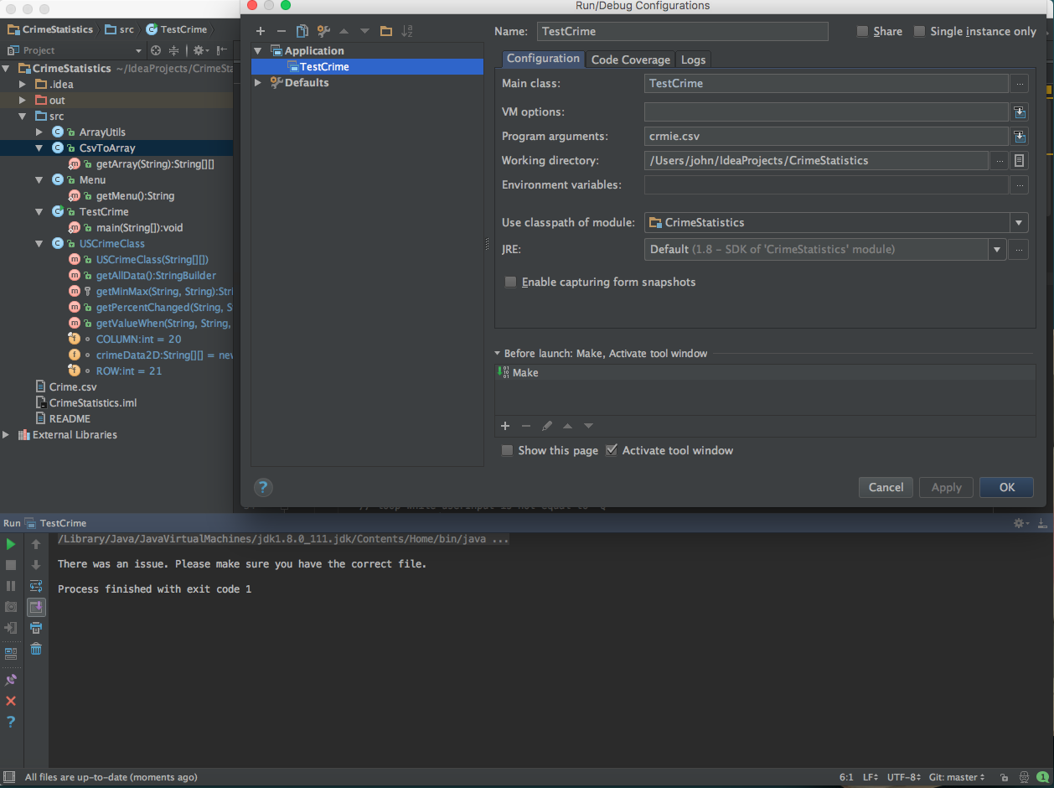**Test Case 3: Correct argument**

|  |  |  |  |
| --- | --- | --- | --- |
| **Command entered** | **Expected output** | **Actual output** | **Pass/fail** |
| Java TestCrime Crime.csv | (menu) | (menu) | pass |

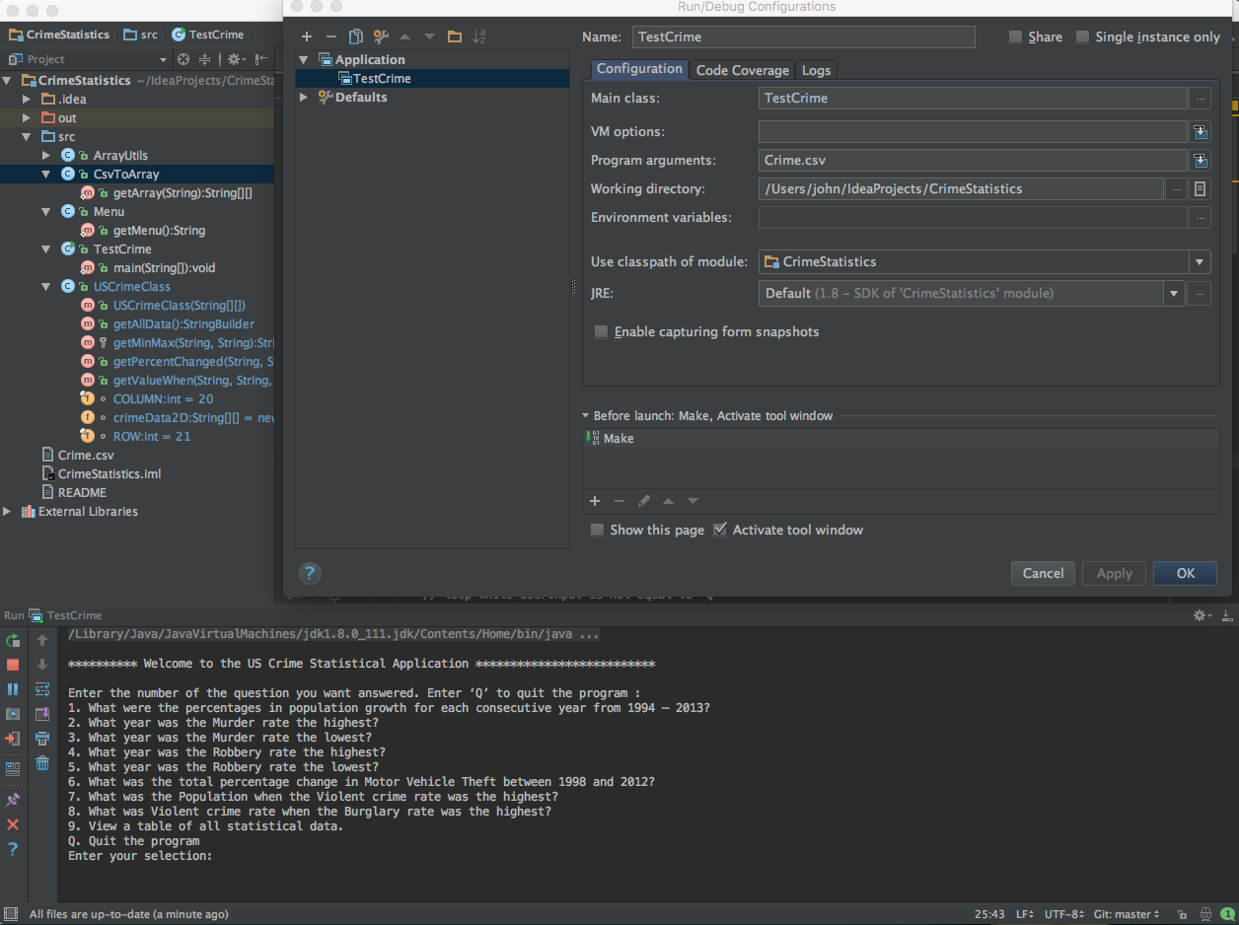**Test Case 4: Correct argument – 1**

|  |  |  |  |
| --- | --- | --- | --- |
| **Command entered** | **Expected output** | **Actual output** | **Pass/fail** |
| Java TestCrime Crime.csv | (menu) | (menu) | pass |

|  |  |  |  |
| --- | --- | --- | --- |
| **UserInput** | **Expected Output** | **Actual Output** | **Pass/Fail** |
| 1 | you have chosen: 1  The percentage change for Population from 1994 to 1995 was 0.951209363702587%.  The percentage change for Population from 1995 to 1996 was 0.9228560758123884%.  The percentage change for Population from 1996 to 1997 was 0.9633332414880249%.  The percentage change for Population from 1997 to 1998 was 0.9202938251556227%.  The percentage change for Population from 1998 to 1999 was 0.9039141724943663%.  The percentage change for Population from 1999 to 2000 was 3.2018288052850536%.  The percentage change for Population from 2000 to 2001 was 1.3842749682748579%.  The percentage change for Population from 2001 to 2002 was 0.9310205124809722%.  The percentage change for Population from 2002 to 2003 was 0.9775371189510894%.  The percentage change for Population from 2003 to 2004 was 0.9862361494749375%.  The percentage change for Population from 2004 to 2005 was 0.970595127492381%.  The percentage change for Population from 2005 to 2006 was 0.9751615999458442%.  The percentage change for Population from 2006 to 2007 was 0.7423795105121508%.  The percentage change for Population from 2007 to 2008 was 0.8084867203131908%.  The percentage change for Population from 2008 to 2009 was 0.9691602561607272%.  The percentage change for Population from 2009 to 2010 was 0.7568792913375952%.  The percentage change for Population from 2010 to 2011 was 0.7298339642658709%.  The percentage change for Population from 2011 to 2012 was 0.7336195071247587%.  The percentage change for Population from 2012 to 2013 was 0.7184909432595472%.  (return menu) | you have chosen: 1  The percentage change for Population from 1994 to 1995 was 0.951209363702587%.  The percentage change for Population from 1995 to 1996 was 0.9228560758123884%.  The percentage change for Population from 1996 to 1997 was 0.9633332414880249%.  The percentage change for Population from 1997 to 1998 was 0.9202938251556227%.  The percentage change for Population from 1998 to 1999 was 0.9039141724943663%.  The percentage change for Population from 1999 to 2000 was 3.2018288052850536%.  The percentage change for Population from 2000 to 2001 was 1.3842749682748579%.  The percentage change for Population from 2001 to 2002 was 0.9310205124809722%.  The percentage change for Population from 2002 to 2003 was 0.9775371189510894%.  The percentage change for Population from 2003 to 2004 was 0.9862361494749375%.  The percentage change for Population from 2004 to 2005 was 0.970595127492381%.  The percentage change for Population from 2005 to 2006 was 0.9751615999458442%.  The percentage change for Population from 2006 to 2007 was 0.7423795105121508%.  The percentage change for Population from 2007 to 2008 was 0.8084867203131908%.  The percentage change for Population from 2008 to 2009 was 0.9691602561607272%.  The percentage change for Population from 2009 to 2010 was 0.7568792913375952%.  The percentage change for Population from 2010 to 2011 was 0.7298339642658709%.  The percentage change for Population from 2011 to 2012 was 0.7336195071247587%.  The percentage change for Population from 2012 to 2013 was 0.7184909432595472%.  (return menu) | Pass |

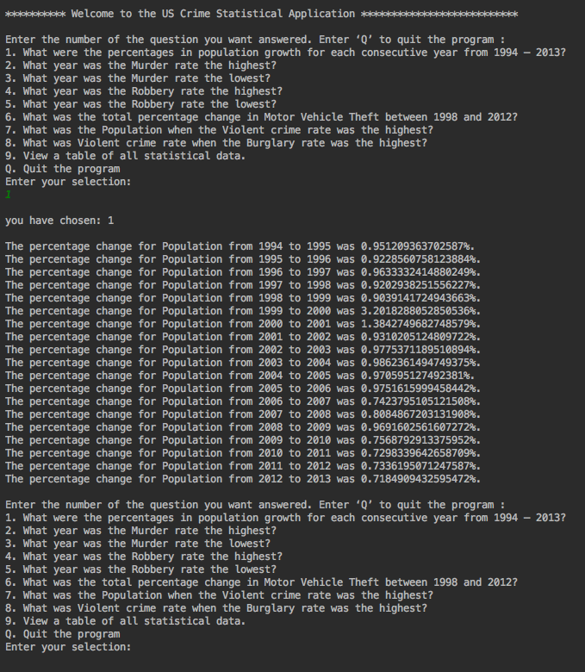**Test Case 5: Correct argument – 2**

|  |  |  |  |
| --- | --- | --- | --- |
| Command entered | Expected output | Actual output | Pass/fail |
| Java TestCrime Crime.csv | (menu) | (menu) | pass |

|  |  |  |  |
| --- | --- | --- | --- |
| **UserInput** | **Expected Output** | **Actual Output** | **Pass/Fail** |
| 2 | you have chosen: 2  The highest Murder and nonnegligent manslaughter rate was at 9.00 in 1994.  (return menu) | you have chosen: 2  The highest Murder and nonnegligent manslaughter rate was at 9.00 in 1994.  (return menu) | Pass |

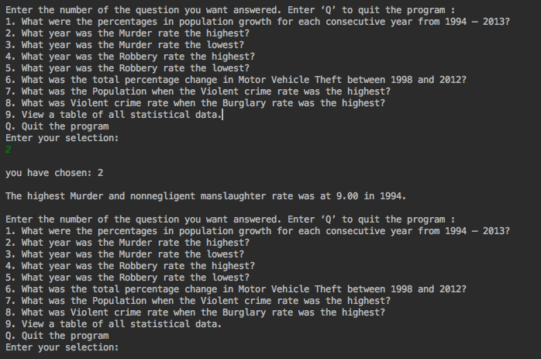**Test Case 6: Correct argument - 3**

|  |  |  |  |
| --- | --- | --- | --- |
| Command entered | Expected output | Actual output | Pass/fail |
| Java TestCrime Crime.csv | (menu) | (menu) | pass |

|  |  |  |  |
| --- | --- | --- | --- |
| **UserInput** | **Expected Output** | **Actual Output** | **Pass/Fail** |
| 3 | you have chosen: 3  The lowest Murder and nonnegligent manslaughter rate was at 4.50 in 2013.  (return menu) | you have chosen: 3  The lowest Murder and nonnegligent manslaughter rate was at 4.50 in 2013.  (return menu) | Pass |

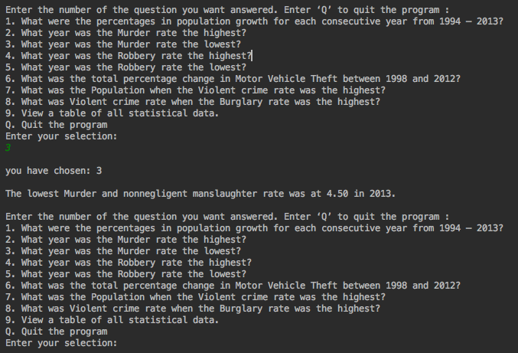**Test Case 7: Correct argument - 4**

|  |  |  |  |
| --- | --- | --- | --- |
| Command entered | Expected output | Actual output | Pass/fail |
| Java TestCrime Crime.csv | (menu) | (menu) | pass |

|  |  |  |  |
| --- | --- | --- | --- |
| **UserInput** | **Expected Output** | **Actual Output** | **Pass/Fail** |
| 4 | you have chosen: 4  The highest Robbery rate was at 237.80 in 1994.  (return menu) | you have chosen: 4  The highest Robbery rate was at 237.80 in 1994.  (return menu) | Pass |

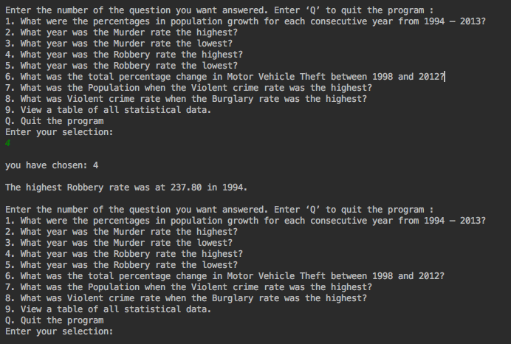**Test Case 8: Correct argument - 5**

|  |  |  |  |
| --- | --- | --- | --- |
| Command entered | Expected output | Actual output | Pass/fail |
| Java TestCrime Crime.csv | (menu) | (menu) | pass |

|  |  |  |  |
| --- | --- | --- | --- |
| **UserInput** | **Expected Output** | **Actual Output** | **Pass/Fail** |
| 5 | you have chosen: 5  The lowest Robbery rate was at 109.10 in 2013.  (return menu) | you have chosen: 5  The lowest Robbery rate was at 109.10 in 2013.  (return menu) | Pass |

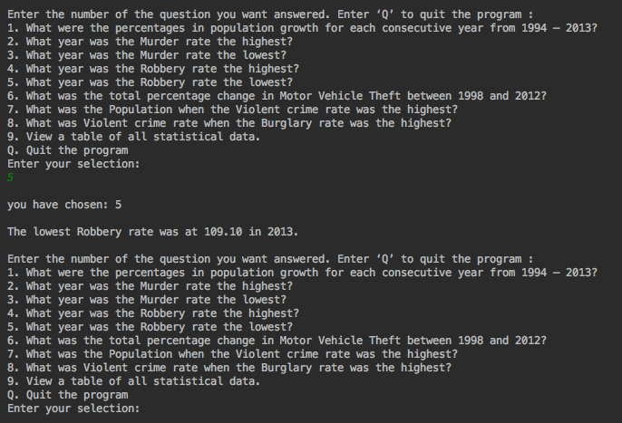**Test Case 9: Correct argument - 6**

|  |  |  |  |
| --- | --- | --- | --- |
| Command entered | Expected output | Actual output | Pass/fail |
| Java TestCrime Crime.csv | (menu) | (menu) | pass |

|  |  |  |  |
| --- | --- | --- | --- |
| **UserInput** | **Expected Output** | **Actual Output** | **Pass/Fail** |
| 6 | you have chosen: 6  The percentage change for Motor Vehicle Theft from 1998 to 2012 was 0.7007007007007007%.  (return menu) | you have chosen: 6  The percentage change for Motor Vehicle Theft from 1998 to 2012 was 0.7007007007007007%.  (return menu) | Pass |

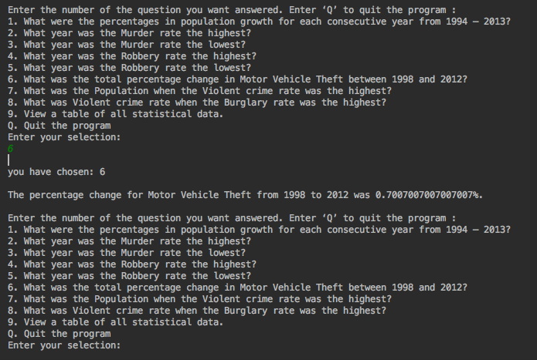**Test Case 10: Correct argument - 7**

|  |  |  |  |
| --- | --- | --- | --- |
| Command entered | Expected output | Actual output | Pass/fail |
| Java TestCrime Crime.csv | (menu) | (menu) | pass |

|  |  |  |  |
| --- | --- | --- | --- |
| **UserInput** | **Expected Output** | **Actual Output** | **Pass/Fail** |
| 7 | you have chosen: 7  The Population was at 260327021 when Violent crime rate was at it's highest in 1994.  (return menu) | you have chosen: 7  The Population was at 260327021 when Violent crime rate was at it's highest in 1994.  (return menu) | Pass |

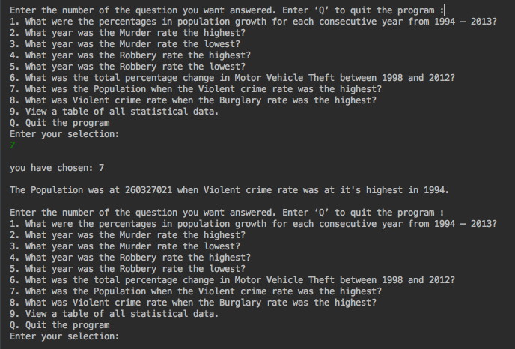**Test Case 11: Correct argument - 8**

|  |  |  |  |
| --- | --- | --- | --- |
| Command entered | Expected output | Actual output | Pass/fail |
| Java TestCrime Crime.csv | (menu) | (menu) | pass |

|  |  |  |  |
| --- | --- | --- | --- |
| **UserInput** | **Expected Output** | **Actual Output** | **Pass/Fail** |
| 8 | you have chosen: 8  The Violent crime rate was at 713.60 when Burglary rate was at it's highest in 1994.  (return menu) | you have chosen: 8  The Violent crime rate was at 713.60 when Burglary rate was at it's highest in 1994.  (return menu) | Pass |

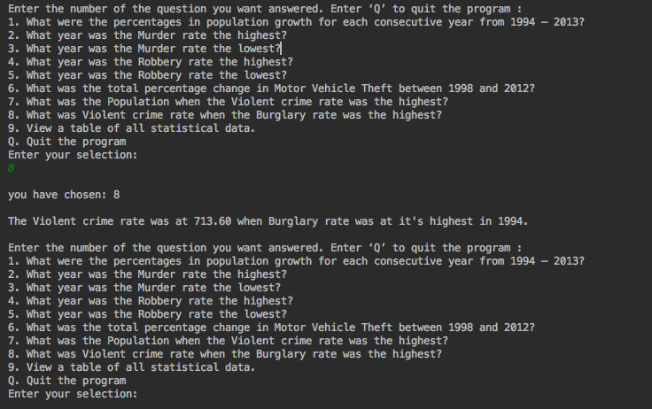**Test Case 12: Correct argument - 9**

|  |  |  |  |
| --- | --- | --- | --- |
| Command entered | Expected output | Actual output | Pass/fail |
| Java TestCrime Crime.csv | (menu) | (menu) | pass |

|  |  |  |  |
| --- | --- | --- | --- |
| **UserInput** | **Expected Output** | **Actual Output** | **Pass/Fail** |
| 9 | you have chosen: 9  ********** US Crime Statistical Data **********  (table output of all statistical data from csv)  (return menu) | you have chosen: 9  ********** US Crime Statistical Data **********  (table output of all statistical data from csv)  (return menu) | Pass  (caveat: need to format spacing better) |

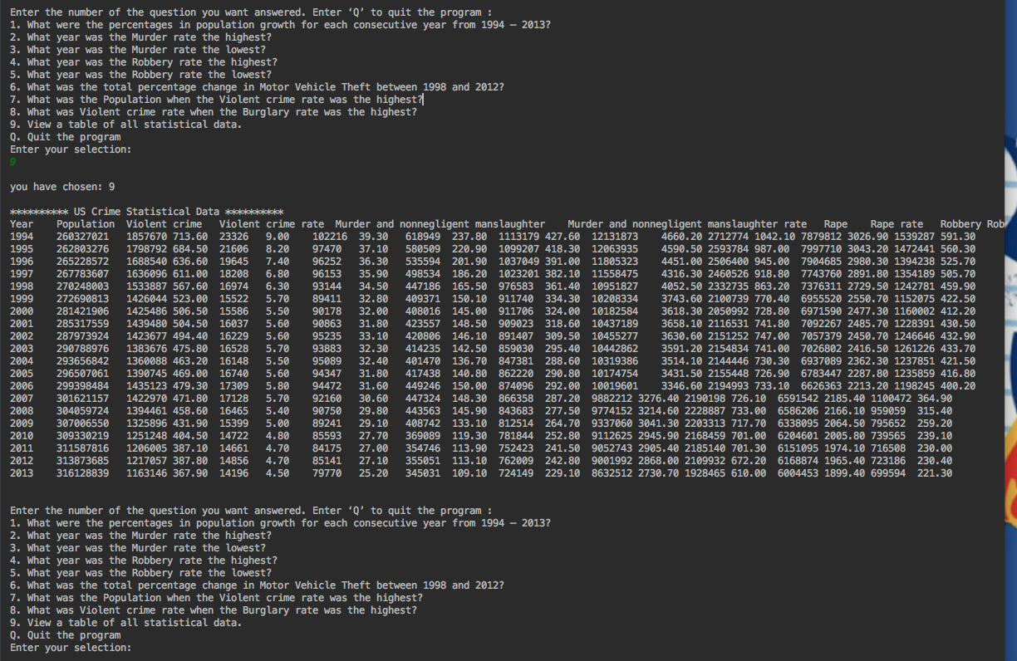**Test Case 13: Correct argument – non-menu items**

|  |  |  |  |
| --- | --- | --- | --- |
| Command entered | Expected output | Actual output | Pass/fail |
| Java TestCrime Crime.csv | (menu) | (menu) | pass |

|  |  |  |  |
| --- | --- | --- | --- |
| **UserInput** | **Expected Output** | **Actual Output** | **Pass/Fail** |
| 0 (zero) | Invalid selection. Please choose again.  (return menu) | Invalid selection. Please choose again.  (return menu) | Pass |
| u | Invalid selection. Please choose again.  (return menu) | Invalid selection. Please choose again.  (return menu) | Pass |
| hello | Invalid selection. Please choose again.  (return menu) | Invalid selection. Please choose again.  (return menu) | Pass |

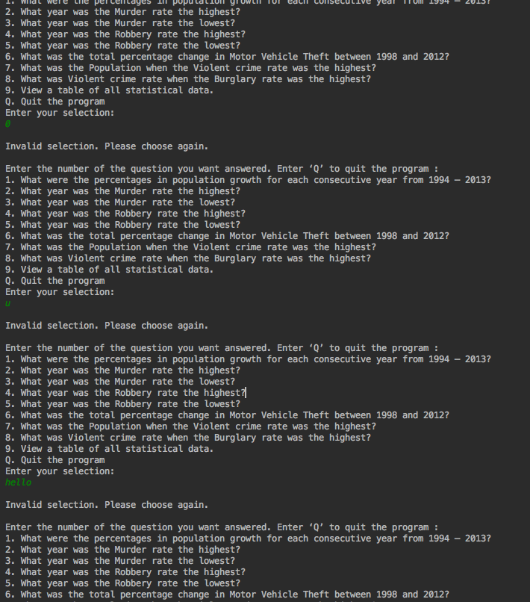**Test Case 14: Correct argument – Q or q**

|  |  |  |  |
| --- | --- | --- | --- |
| Command entered | Expected output | Actual output | Pass/fail |
| Java TestCrime Crime.csv | (menu) | (menu) | pass |

|  |  |  |  |
| --- | --- | --- | --- |
| **UserInput** | **Expected Output** | **Actual Output** | **Pass/Fail** |
| Q | Thank you for trying the US Crimes Statistics Program  Elapsed time in seconds was: (seconds elapsed since program started) | Thank you for trying the US Crimes Statistics Program  Elapsed time in seconds was: 1262 | Pass |
| q | Thank you for trying the US Crimes Statistics Program  Elapsed time in seconds was: (seconds elapsed since program started) | Invalid selection. Please choose again.  (return menu) | Pass |

